MASCHERPA Audric ROB 3 2022 / 2023

**POLY-SNAKE**

**Weekly report n°16 from 12/03/23 :**

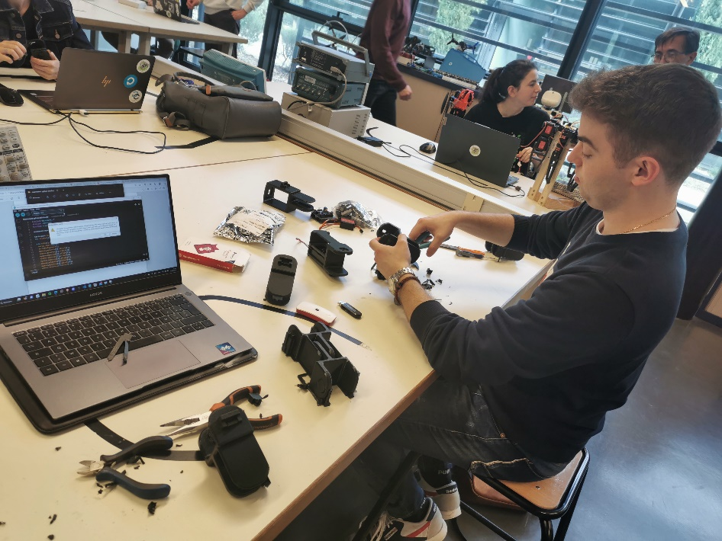For this session, we did a lot of testing and checking out a theory we had regarding the motion of the snake without a motor. However, we first started by removing all the supports present on the many parts of the Polysnake once the 3D printing was finished in figure 16.1

Figure 16.1

So once the parts were completely cleaned, we were able to carry out the tests that we took on video and that we broadcast on the youtube platform.

<https://www.youtube.com/watch?v=C6OPcSumDQM> (straight ahead)

<https://www.youtube.com/watch?v=HqG8QPvNAjo> (movement to the left)

<https://www.youtube.com/watch?v=mZjUm6wLaqU> (movement to the right)

The idea we had was that more of the work on the slithering motion was made by the friction. And as it was pretty complicated to make a snake skin we have chosen Rubber wheels (as they will roll if the force that they receive is parallel to them and will be blocked more and more by friction as the force get perpendicular to them)

then we used these different programs to make it move:

* the first test worked but with some problems, as the snake makes too large movements, we have too much friction. However, we can modify the parameters on the movement of the snake in the program.
* After several tests, we realized that we had to find a balance between amplitude and wavelength (at some point to increase the amplitude but avoid too much friction, we had to increase the wavelengths which decrease in does the amplitude).
* we kept the characteristics that worked well with an offset of 3 (to fix a fault either at design or initialization that caused the snake to go slightly to the right) an amplitude of 43, a speed and a length of wave of 2 (these measurements have no equivalent with reality for the moment because the different characteristics change as we modify the parts so we must take measurements to find the given coefficient in reality) .

the line of code looked like this in code: slip (3,43,2,2)

here is the link to the programs : <https://github.com/YOUSSNDR/PolySnake/tree/main/programmes/Classes/mouvement>